Заявка на участие в межвузовском конкурсе перевода «Lingua Franca – 2022»

ФИО (полностью)__________________
Возраст (полных лет) _______________
Место учебы: университет (полностью)______
Факультет/Школа_________________________
Направление подготовки___________________
Курс, группа _____________________________
Контактный телефон ______________________
Электронная почта ________________________

Конкурсное задание

Номинация «Перевод научного текста
с английского языка на русский»

Внимание! Переводу на конкурс подлежат только следующие разделы статьи: 1) “Abstract”, 2) “1. INTRODUCTION.”

Attitudes to English in contemporary Malaysia
Jia Chi Ng, Chloé Diskin-Holdaway

Abstract
This paper examines the attitudes that Malaysians of different backgrounds hold towards the English language in Malaysia, as well as how they perceive ‘Standard Malaysian English’ and ‘Colloquial Malaysian English’, in terms of status and solidarity. The study administered an online questionnaire, which included an embedded matched-guise experiment, to 77 Malaysian respondents in Malaysia and Australia. Findings indicated a range of divergent and at times contradictory views of Malaysian English, illuminating how Malaysians are in different stages of acceptance of Malaysian English as a legitimate variety of English. Through an examination of individual participant responses, the study also shows that Malaysians are attuned to and hold certain stereotypes towards ‘ethnic’ varieties or ‘ethnolects’ of Malaysian English, providing insight into how issues of race and ethnicity, embedded within the broader socio-political context and language ecology of the nation, have influenced contemporary language attitudes.

1 INTRODUCTION

The study of world Englishes has brought to light how localised or indigenised varieties of English have diversified over time, both in their domains of use and in their linguistic structure. The presence of the English language in Malaysia, and its long history of contact with other languages, has led to the emergence of a distinctive variety of English, known as Malaysian English (MalE). This is evident in its syntactic, lexical, stylistic and phonological features and patterns that differentiate it from other varieties of English around the world (see Baskaran, 1987; Pillai, 2008; 2012; Platt & Weber, 1980; Rajadurai, 2004; Wong, 1983).
Malaysian English was originally characterised in terms of an acrolect, mesolect, and basilect (Platt & Weber, 1980), although it is now known that factors such as education and the linguistic background of speakers inevitably influence their ability to move along this continuum, depending on the context or the interaction (Govindan & Pillai, 2009).
Furthermore, Malaysian English as a variety is characteristically heterogenous (Pillai, 2012), although heterogeneity in itself is not unique to Malaysian English, but is found in all varieties. The basilectal form of Malaysian English, Colloquial Malaysian English, also popularly known as ‘Manglish’, has been referred to as ‘broken’, ‘stigmatised’ and ‘internationally unintelligible’ due to its ‘substantial divergence’ from perceived standard varieties of English (Baskaran, 1994, p. 29). Colloquial Malaysian English is associated with people who have had limited education or proficiency in English (Morais, 1998). Nonetheless, for most Malaysians, the more basilectal form of Malaysian English is the preferred code for expressing solidarity and camaraderie, as it indicates a localised Malaysian identity (Pillai & Ong, 2018; Rajadurai, 2013).
Contradictions can arise in investigations of attitudes towards Malaysian English, as for some speakers, ‘Malaysian English’ represents Colloquial Malaysian English, or ‘Manglish’; whereas for others, it represents ‘Standard Malaysian English’, and distinctions are also made between acceptability of these varieties in speaking versus writing, leading to unresolved norms of standardness (Pillai & Ong, 2018, p. 150). The heterogeneity of Malaysian English is furthered by the presence of ‘ethnolects’, with researchers proposing that Malaysians’ race/ethnicity can be easily identified by speakers of Malaysian English (Morais, 1998; Nair-Venugopal, 2000). In Singapore, there is a similar language ecology, with four languages listed as official (designed to correspond to the main ethnic groups): Malay, Mandarin Chinese, Tamil and English (Tan, 2012). In the present paper, the term ‘Malaysian English’ is used to refer to all varieties of English as spoken in Malaysia collectively. The term ‘Standard Malaysian English’ is used to refer to the acrolectal or ‘official Malaysian English’, and ‘Colloquial Malaysian English’ is used to refer broadly to the non-acrolectal varieties.
Since Kachru’s (1985) influential work on the concentric circles of English, there has been an increased awareness of both the diversity of Englishes around the world, and the nature of their expansion, coupled with a more critical view of the oftentimes ‘unequal’ status of some varieties of Englishes vis-à-vis others. The world Englishes paradigm places many post-colonial countries in the Outer Circle, such as India, Singapore or Hong Kong, and indeed Malaysia. In the Outer Circle, the English language generally has a different status as compared to Inner Circle territories, whereby its use may be viewed as a marker of prestige and class, but not necessarily as a carrier of local identity. Furthermore, the varieties of English that have evolved in Outer and Expanding Circle territories, with their influence from a wide variety of local languages, can often be viewed, somewhat problematically, as ‘inferior’, ‘broken’ or somehow deficient as compared to the Englishes of the Inner Circle, in particular British or American English (see Diskin & Regan, 2017; Widdowson, 1994). With increased globalisation, and the position of English as the most commonly-learned language in the world, there is an impetus to better understand how English is being used and perceived in Outer Circle territories. This paper provides insight into current attitudes and perceptions of English in Malaysia, investigating its place in the multilingual repertoire of Malaysians, as well as how it is evaluated as a variety in its own right, with particular reference to its perceived ethnolectal differences. These themes and issues are explored by means of an online survey with an embedded matched guise test completed by 77 Malaysians in 2017.

2 ENGLISH IN MALAYSIA

Malaysia, comprising East and West Malaysia, is a culturally and linguistically heterogeneous country with an estimated total population of 32.7 million (Department of Statistics Malaysia, 2020). The ethnic makeup of the total population is roughly 69.6% bumiputera (‘sons of the soil’ – a term used to refer to Malays and other indigenous groups); 22.6% Chinese; 6.9% Indian; and 1.0% ‘Other’ (Department of Statistics Malaysia, 2020). When Malaysia declared independence in 1957, Bahasa Malaysia (Malay), the language of the dominant ethnic group, was declared the national language, and strongly promoted to assert national identity. Meanwhile, English was accorded the status of a second language, followed by the gradual phasing out of English-medium schools at the primary and secondary level. Since then, there has been a conflict within Malaysia between how to ‘uphold and promote Malay nationalism on the one hand’ and ‘to recognise [...] the pragmatic, academic and global importance of the English language on the other hand’ (Manan et al., 2015, p. 34).
David and Govindasamy (2005, p. 125) propose that the affirmation of Malay as the national and official language has resulted in monolingualism for the Malay community, especially in rural areas. In contrast, the Chinese and Indian communities are reported to be more invested in maintaining English in their linguistic repertoire, giving them a ‘competitive edge’ over the Malays, who are seen as least likely to shift to the English language (Tan, 2013, p. 36). Despite these tensions between English and the other languages of Malaysia, English, and especially Malaysian English, provides a form of ‘linguistic glue’ (Kirkpatrick, 2010, p. 28), especially in the more urban areas of Malaysia.
In the Dynamic Model of New Englishes, Schneider (2003a, p. 260) presents Malaysia at Phase 3 (the nativisation phase) and as an example of ‘fossilised development’, adopting the term ‘fossilised’ from the notion of ’fossilisation’ (halted development somewhere along a learner’s process of progressively acquiring L2 rules) in second language acquisition. This arguably accentuates the ‘interlanguage’ nature of Malaysian English. He argues that, instead of progressing to the endonormative stabilisation stage (Phase 4), the development of Malaysian English has been halted at the nativisation phase as a result of nationalistic language policies promoting the use of Malay over English, although English is still used as a second lingua franca (Asmah, 1996, p. 526). In the nativisation phase, there is ‘the heaviest effects of the restructuring of the English language itself’ (Schneider, 2003a, p. 248) and there is a gradual shift away from the distant ‘mother country’ (former coloniser) in terms of political power and linguistic and cultural guidance. This phase is also marked by a characteristic ‘complaint tradition’ (Milroy & Milroy, 1991, p. 29), where there arises a heightened linguistic awareness, accompanied by an increase in stereotypical statements about deteriorating language use, indicating insecurity surrounding the acceptance of local usages over the older, external form as the only ‘correct’ and ‘proper’ norm and as the preferred pedagogic model.

3 LANGUAGE ATTITUDES AND LINGUISTIC INSECURITY

Language attitude studies offer valuable insights into the types of judgements and attitudes that listeners hold towards certain varieties or linguistic features and their speakers (Garrett et al., 2003). Furthermore, the term ‘linguistic insecurity’ (Labov, 1986), refers to a situation where speakers are led to feel that the variety they speak is somehow less correct or less prestigious, in contrast to the existence of a separate, ideal standard form of a language that they aspire to, but fall short of, sometimes leading them to change features of their speech. There has been relatively little research into language attitudes in a Malaysian context. Crismore et al. (1996, p. 319) looked at the attitudes of Malaysian university students and instructors towards the use and acceptance of what they termed ‘Standard English’ versus ‘Malaysian English’, and found that both students and teachers were determined to learn ‘Standard English’, and they regarded Malaysian English as ‘wrong’. Gill (1993, pp. 234–235) investigated standards for English language teaching in Malaysia, and it was shown that while participants still indicated a preference for the ‘RP accent’ as the most suitable teaching model, there was a growing acceptance for an ‘indigenised’ but ‘standard’ English. Of the respondents, 79.2% preferred an unmarked accent which is ‘neither strongly Malaysian nor strongly RP, and almost without grammatical mistakes’, though speakers with recognisably ethnic accents were still evaluated negatively and seen as unsuitable to be used as a teaching model. Tokumoto and Shibata (2011), looking at the attitudes that Japanese, Korean, and Malaysian learners have towards their own variety of English, found that the Malaysians had the highest level of acceptance towards Malaysian English, and were the least bound by the idea of having to adhere to a ‘native’-like English pronunciation.
Previous studies on the relationship between ethnic identity and attitudes towards English in Malaysia have indicated ambivalence, in particular among the Malay-Muslim community, to engage with the English language, which could be seen as ‘un-Islamic’ (Ratnawati, 2005) and a ‘threat’ to ethnic and national identity (Mardziah & Wong, 2006, p. 15). Coluzzi (2016) utilised the matched-guise test to investigate attitudes towards English, Chinese and Malay among fifty university students of Chinese and Malay background in Kuala Lumpur and found that all respondents attributed higher status and prestige to English as compared to their own languages. Lee (2003, p. 245) found that among ESL learners in Malaysia, Malay participants reported feeling the most discomfort when speaking English, and showed reluctance to use English among fellow Malays to avoid the risk of being teased and seen as ‘showing off’ and ‘elitist’. There has to date been few studies of an experimental nature that have examined Malaysian listeners’ perceptions of ethnic differences (or ‘ethnolects’) in Malaysian English; however, in other English-speaking contexts, listeners have been found to identify the ethnicity of different speakers within their communities with relatively high accuracy (Newman & Wu, 2011; Szakay, 2012; Thomas & Reaser, 2004).

4 RESEARCH QUESTIONS

In light of the discussion presented above, the current paper set out to answer the following research questions: first, what attitudes do Malaysians hold towards the English language more generally, and Malaysian English as a variety specifically? Second, how are Standard Malaysian English and Colloquial Malaysian English evaluated by Malaysians in terms of status and solidarity? Finally, how do Malaysians perceive ethnic varieties of Malaysian English, and to what extent are they aware of potential ethnolectal differences?

5 METHODOLOGY

Data were collected for this study by means of an online survey hosted on Survey Monkey®. The survey was open for three weeks in July 2017 and completed by 77 adult Malaysians. Criteria for participation were that respondents had to be over 18 years of age and Malaysian citizens, but, with the aim of gaining a holistic view of the attitudes towards Malaysian English, there was no requirement that the respondents be currently residing in Malaysia. Out of the 77 respondents, 36 (46.75%) chose to provide their country of residence (an optional question), with 15 respondents residing in Malaysia, 15 in Australia, four in Taiwan and two in Singapore.¹ All participants gave informed consent to participate in the study and all of their responses were kept strictly anonymous. The survey was circulated among the personal networks of the first author, and then re-circulated, or ‘snowballed’, by individuals in these networks. The survey consisted of three parts and took approximately fifteen minutes to complete. Respondents were informed that they needed to be in a quiet place, and the use of headphones was recommended. Parts 1 and 2 consisted of both closed and open-ended questions pertaining to the participants’ views of English in Malaysia. Part 3 consisted of an embedded matched-guise test, the design of which is described below. Originally, the study hoped to investigate any possible background variable that could contribute to differences in language attitudes, hence recruiting Malaysians living both in Malaysia and in a majority English-speaking country like Australia. However, many respondents chose to leave questions about their background unanswered, so this has not been included as a variable in the quantitative analysis.
5.1 The matched guise test

In the matched guise method (see Lambert et al., 1960), balanced bilingual (or bidialectal) speakers record the same text or conversation in each of their languages/varieties. Respondents listen to both recordings, and evaluate speakers on the basis of the guises alone. As respondents are not given any background information about the speakers, the different evaluations of the speakers are presumed to be solely based on their attitudes towards the languages/varieties themselves. Respondents are not explicitly told that the two guises are spoken by the same speaker. Compared to a more direct method, these indirect methods emphasise ‘the elicitation of spontaneous attitudes less sensitive to reflection and social desirability biasesTM (Ryan et al., 1987, p. 1072). In the present study, respondents listened to two audio-recorded conversations created specifically for the online survey using (untrained, volunteer) voice actors. The conversations were played to survey respondents via two embedded YouTube videos, which showed a black screen

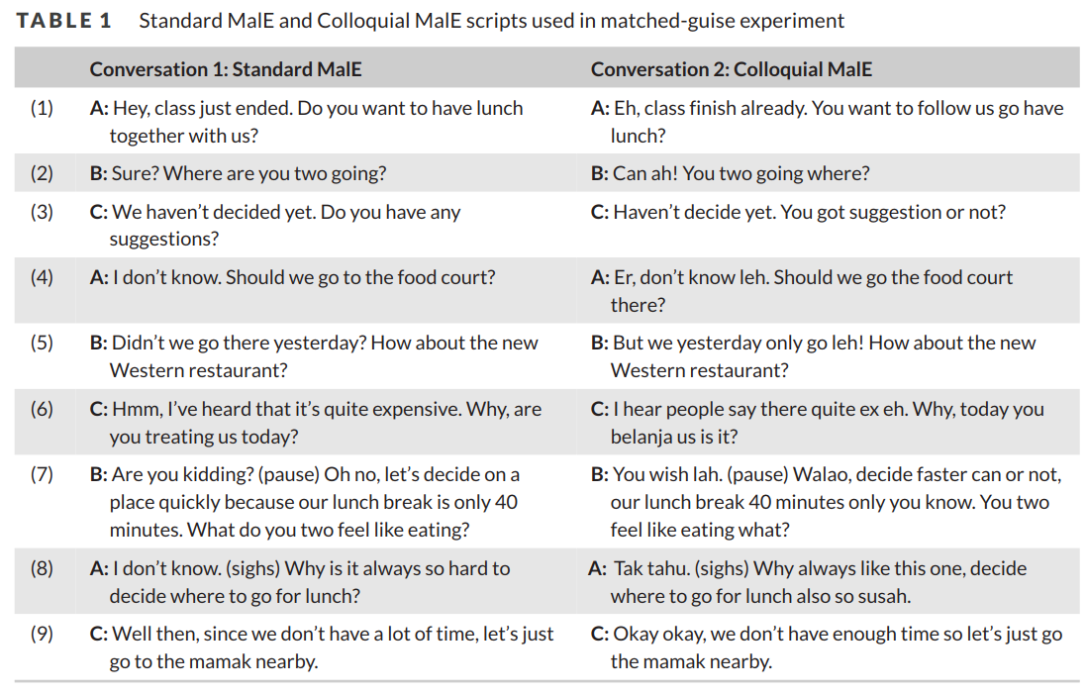
overlaid with subtitles of the two recordings (see Table 1). Subtitles were chosen to accompany the recordings, as there was no guarantee that the respondents were listening to the guises in a quiet place, even if they were encouraged to do so. There is a possibility that respondents would have reacted differently and perhaps less strongly or negatively to spoken colloquial Malaysian English (with no subtitles), than to colloquial Malaysian English accompanied by its written form, in this case via subtitles. However, the use of subtitling for videos on social media sites such as YouTube is becoming increasingly prevalent, with rapid advancements being made in auto-captioning. It is likely that the respondents were familiar with this format and in that case, less likely to be affected by the presence of subtitles.
Conversation 1 was scripted to represent Standard Malaysian English, and Conversation 2 was scripted to represent Colloquial Malaysian English. Each conversation had three speakers (actors): one Chinese Malaysian (female), one Malay Malaysian (male) and one Indian Malaysian (male). The speakers were university undergraduates in their early twenties who lived in the same urban area of Malaysia and were all multilingual: all three reported English as a main language in addition to the other languages they spoke (Mandarin, Malay and Tamil respectively). They were deliberately chosen to represent the three main ethnic groups in Malaysia, while at the same time their similarity in terms of age, level of education and place of residence mitigates somewhat the effect of geographic or age-based differences across their accents. Nonetheless, the actors were not told to specifically emphasise any aspect of their ethnic background during the recordings. They were told that they could make small changes to the script provided, in order to simulate a conversational exchange that flowed and sounded natural as much as possible. The script provided in Table 1 represents the final version that was recorded and played to participants as part of the survey.
In Conversation 1 (Standard Malaysian English), although the intonation and pronunciation of the speakers clearly identify them as speakers of Malaysian English, the script does not include much nativisation, with the exception of the Malay loanword mamak.² Conversation 2, the Colloquial Malaysian English version, includes distinct indigenised discourse and grammatical forms: discourse markers such as lah (line 7), leh (lines 4, 5), eh (line 6), ah (line 2) and one (line 8), as well as features such as the invariant or not question tag (line 7) and lack of inversion in wh-questions (you two going where in line 2; you two feel like eating what in line 7). Instances of code-mixing, such as in lines 6 and 8, which sees the use of Malay lexical items such as belanja (‘to treat’), and susah (‘hard, difficult’), also reflect colloquial speech.
In both versions of the script, the speakers debate over where to go for lunch before arriving at a decision: this topic of conversation was deemed a neutral topic that would not influence listeners’ evaluations of the speakers.
Respondents were asked to evaluate each of the three speakers twice (once per guise), according to a set of traits designed to fit broadly under the themes of ‘status’ and ‘solidarity’, which are themes commonly examined in language attitude surveys (see Giles & Billings, 2004). On the status dimension, respondents were asked to evaluate, on a scale of 1 to 5, whether or not each speaker was easy to understand (clear), and the degree to which they sounded ‘educated’ and ‘professional’. On the solidarity dimension, respondents evaluated the degree to which speakers were ‘friendly’, ‘likeable’, ‘sociable’ and ‘Malaysian’. An optional section for comments was provided for each speaker. For each speaker in each guise, the order in which respondents were presented with the seven traits to evaluate them was randomised. The respondents were not informed that it was the same set of speakers; however, due to the functionalities of embedding YouTube videos into Survey Monkey®, it was not possible to randomise the order in which respondents listened to the recordings, meaning the Standard Malaysian English always preceded the Colloquial Malaysian English recording. This limitation, coupled with the small set of speaker recordings, meant that some respondents deduced that it was the same set of speakers in the two recordings, which may have influenced some of their responses.

6 RESULTS
6.1 Survey Parts 1 and 2: English in Malaysia
Part 1 of the survey consisted of eight statements about English and its status and utility in Malaysia, followed by six open-ended questions relating to Malaysian English. The first set of statements were based on a language attitude survey employed in Kircher (2009). As direct and indirect methods of attitude elicitation may produce different and occasionally conflicting responses, Ryan et al. (1987, p. 1076) argues that it is better to use at least two or more types of attitude measurement. Thus, the current research draws on Kircher’s (2009) study, since it employs both direct and indirect techniques of measuring language attitudes to contrast the attitudes held by four groups of Quebecers towards Quebec French versus European French. Respondents indicated their degree of agreement or disagreement with the statements, following a 5-point Likert scale (1 = don’t agree at all; 5 = completely agree).³ The statements, along with their mean response scores, are summarised in Table 2.
Responses point to a positive overall agreement regarding the instrumental role of English in Malaysian society, with responses to statements A and B indicating that respondents value the English language highly for the opportunities it offers to ‘find employment’ and ‘get far in life’. Statements C, D and E also suggest that most of the respondents have a personal connection to the English language, in that it is an ‘important part of their personal identity’ (D). Value is also placed on the everyday use of English for communication, and on bilingualism, with a mean response rate of 4.45 for the statement ‘Knowing English is as important as my mother tongue’. However, statement F suggests that there are mixed opinions as to whether the English spoken in Malaysia is internationally understood (see also Figure 1), with ‘partially agree’ representing the most frequently-selected response (31/66 responses). Following from that, the scores for statements G and H suggest that respondents lean towards agreement regarding declining English standards, and agreement that the standard of English used in Malaysian media should be improved.
Particularly in light of statement F, responses to the first open-ended question in Part 2 were particularly elucidating:
(1) How would you describe the English spoken in Malaysia?
Here, many respondents referred to the practice of codeswitching and borrowings from local languages such as Malay and Chinese as justifications for their assessment that Malaysian English is not ‘internationally understood’. There were comments that ‘Malaysians love to mix their languages around’, with mentions of stereotypical linguistic

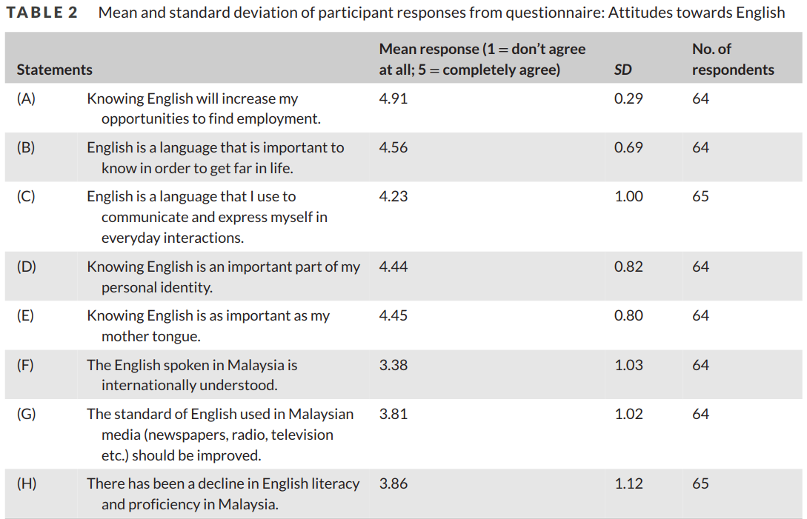

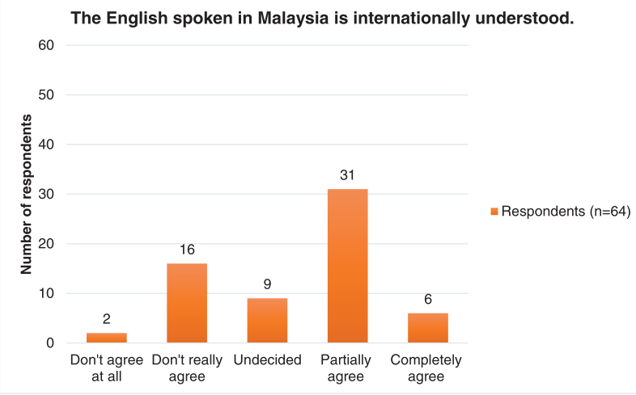

FIGURE 1 Distribution of responses for statement F: ‘The English spoken in Malaysia is internationally understood’ [Colour figure can be viewed at wileyonlinelibrary.com]

features, such as discourse markers, ‘a lot of lah leh lohs’, and loanwords from local languages, ‘our English is quite rojak with a lot of words from different languages thrown in’.⁴
Some responses leaned towards negative evaluations of the localised variety, where English in Malaysia was described as ‘simple words and sentences mixed with words from other languages’; a ‘mixture of fluent and broken English’; ‘made up of ‘a variety of slangs’. This is no doubt linked to the notion of ‘Manglish’, which one respondent referred to as a ‘rojak version of English that is not really standard and grammatical’ and which another criticised as being full of ‘wrong grammars and inaccurate pronunciations’. Others viewed Malaysian English as imperfectly learned English, comparing it to a ‘standard’ or ‘real’ English, which in this case was referred to as British English or American English in 45 out of 61 responses (see below).
Five more open-ended questions followed:
(2) Do you think you have an accent when you speak English?
(3) If so, do you like it? Have other people commented on it?
(4) Can you tell from somebody’s speech whether he/she is from Malaysia? How?
(5) Does everyone in Malaysia speak English the same way?
(6) Where is the best English in the world spoken? Why do you think so?
Overall, these open-ended questions revealed an overarching theme centred on the notion of a ‘standard language’. Respondents frequently contrasted what they saw as their own variety of English (Malaysian English) with other more ‘proper’, ‘correct’, ‘standard’ varieties of English. In response to the sixth question, 45 out of 61 respondents explicitly referred to the United Kingdom (UK) and United States of America (USA) as the place in the world where the ‘best English’ is spoken. The main reasons being that they felt it was ‘the proper English’; ‘the most standard and formal’; ‘their pronunciation is the most accurate’; ‘it’s where native speakers of English are from’; it has ‘the most authentic English’. One respondent referred specifically to ‘RP’ as the ‘best spoken English’. A number of respondents denoted Malaysian English as a variety that could be incomprehensible to speakers of other varieties of English: ‘mix of manglish and singlish can be discerning and worrying culture shock for foreigners’, and ‘would be a problem with average English speaker’.
Responses to the questions also indicated varying levels of linguistic insecurity. While respondents frequently applied terms like ‘proper’ and ‘standard’ to UK and US English, they often referred to Malaysian English as ‘simple English’ and ‘not really proper or standard’. Attitudes were expressed through statements and judgments such as: ‘[English in Malaysia has] deteriorated a lot’ and ‘Malaysians don’t use proper and complete English during daily life’. Many comments referred to it as ‘Manglish’, with one respondent sardonically noting ‘What English? Oh, you mean Manglish’. Insecurity also emerged in anecdotes from the respondents’ own experience with speaking (Malaysian) English: ‘People tend to laugh at me when I pronounce something with the wrong pronunciation’. In response to the second question concerning whether respondents felt they had an accent, and the third question asking whether anyone had ever commented on it, a number of the respondents living overseas reported having become more aware of their use of Malaysian English or their Malaysian accent. There were reports about being mocked or made fun of for their ‘funny’ accents. There were also reports of being made aware while residing overseas that their English was not ‘native’: ‘People have commented that my Malaysian accent is not very strong but they could tell that I’m not a native speaker’.
Some of the responses also suggest that respondents subconsciously perceive a hierarchy of Englishes, as evidenced by comments such as ‘Malaysian and Singaporean generally has a better command of other Asian countries such as China, Korea or Japan’ and ‘I don’t admire English from Myanmar/Philippines/Indonesia especially but UK and US accent is outstanding’. These evaluations align with Kachru’s (1985) Concentric Circles model, with Inner Circle countries such as the UK and the US rated most favourably, followed by Outer Circle countries such as Malaysia and Singapore, and Expanding Circle countries such as China and Korea rated the least favourably. Other types of comparison were also made depending on educational background and ethnicity: ‘People from Chinese school will sound more Manglish’; ‘I come from a Chinese school so of course my English isn’t as good [...] it used to make me feel inferior because you can hear the difference’.
While responses indicated that competency in English is highly valued, there were also responses that indicated it may not always be thought of as desirable. One respondent noted that, if they ‘try and speak proper English’ they would be laughed at by their friends and ridiculed for having ‘an ang moh accent’.⁵ Emulation of a British or American accent was perceived to be ‘too pretentious’ and something to be avoided in use with other Malaysians. One respondent, referring to ‘people with a foreign accent’, remarked that they weren’t sure ‘whether it’s inherent or faked’; another noted that due to the ‘difference’ in their accent they were often accused of ‘faking it’. One respondent noted that being able to manipulate their Malaysian accent ‘makes things less awkward and allows me to avoid uncomfortable situations like people from Malaysia calling me a ‘banana’’, illuminating how some Malaysians are in a position to switch between different varieties along the lectal continuum, depending on who their interlocutor is and how they want to present themselves in a situation.6 Nonetheless, this issue of ‘faking it’ presents a potential ‘double bind’ for Malaysians, as they are caught between wanting to present themselves as highly proficient speakers with prestigious accents, and avoiding coming across as pretentious or contrived.

6.2 Survey Part 3: matched-guise test

In this part of the survey (see also Section 5.1), respondents listened to two audio-recorded, scripted conversations of three Malaysian English speakers of different ethnic backgrounds. Respondents were asked to rate each of the three speakers, in both the ‘Standard Malaysian English’ and the ‘Colloquial Malaysian English’ guises, across three ‘status’ traits (Table 3); and four ‘solidarity’ traits (Table 4). Many respondents also opted to leave open-ended comments explaining the ratings given for each speaker. For each trait, the mean ratings were calculated and paired sample t-tests were run in Excel for each of the three speakers, comparing how they were rated in the Standard Malaysian English guise compared to the Colloquial Malaysian English guise.
For clarity, Standard Malaysian English was evaluated higher than Colloquial Malaysian English overall, but there was no significant difference between the Standard Malaysian English and Colloquial Malaysian English recordings for

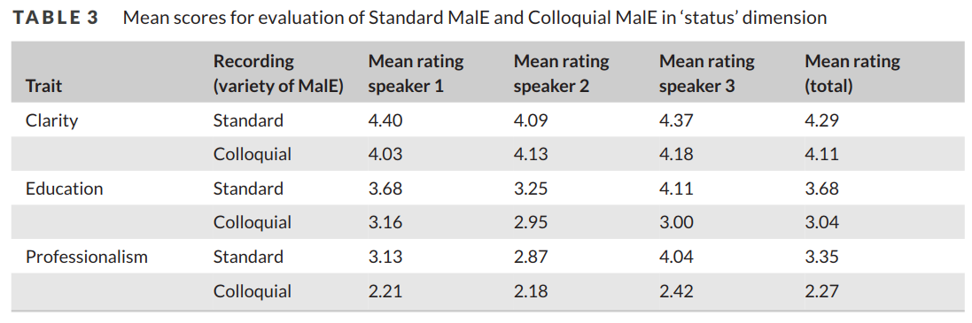

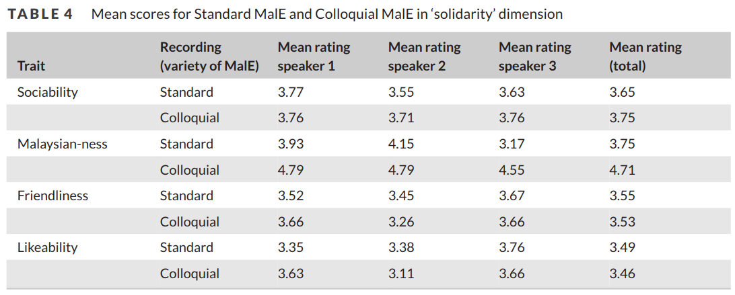

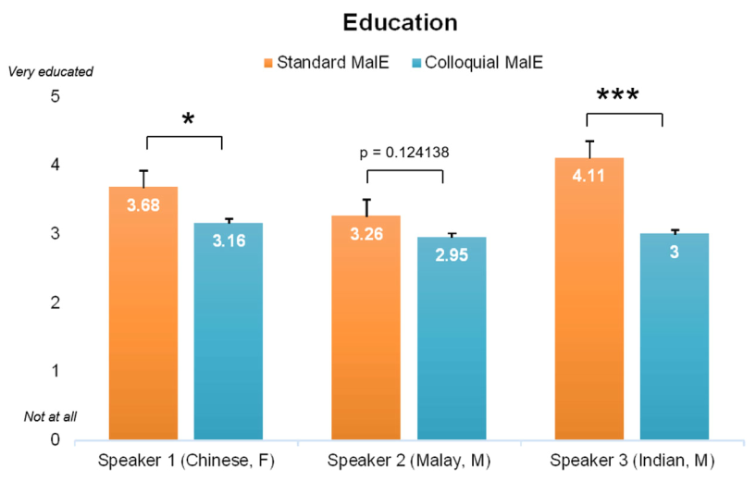
FIGURE 2 Mean evaluations of educatedness in Standard MalE and Colloquial MalE [Colour figure can be viewed at wileyonlinelibrary.com]
Note: Asterisks represent: *p ≤ 0.05; **p ≤ 0.01; ***p ≤ 0.001

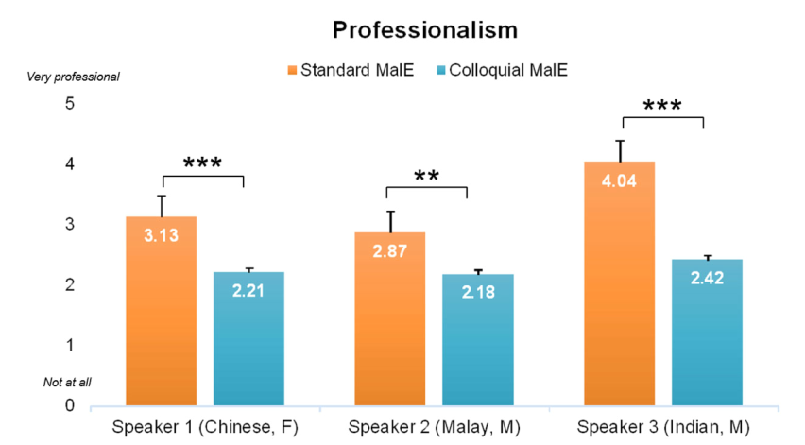

FIGURE 3 Mean evaluations of professionalism in Standard MalE and Colloquial MalE [Colour figure can be viewed at wileyonlinelibrary.com]
Note: Asterisks represent: *p ≤ 0.05; **p ≤ 0.01; ***p ≤ 0.001

all three speakers. The mean ratings for clarity across both recordings were fairly high, ranging from 4.03 to 4.40, indicating that respondents found both guises to be intelligible and easily understood. This presents a somewhat different view to the answers in Part 1, where certain respondents described Malaysian English in general to be hard to understand, although these responses likely referred to the global (un)intelligibility of Malaysian English, versus whether or not the respondents could understand what was being played in the individual recordings. For educatedness, Standard Malaysian English was consistently evaluated as sounding significantly more educated than Colloquial Malaysian English, particularly for Speakers 1 and 3 (Figure 2).
The ratings (Figure 3) also revealed that Standard Malaysian English was evaluated as sounding significantly more professional than Colloquial Malaysian English for all three speakers (p < 0.001 for both Speaker 1 and Speaker 3, and p < 0.01 for Speaker 2). In particular, Speaker 3 was rated as sounding the most professional in the Standard Malaysian English recording, with a mean of 4.04, which by far surpasses the mean of 3.13 for Speaker 1, and 2.87 for Speaker 2. Overall, Colloquial Malaysian English was perceived to be less easy to understand (clear), less educated and less professional as compared to Standard Malaysian English, across all speakers. This difference is especially marked on the level of professionalism: for all speakers, Colloquial Malaysian English was seen as less professional than Standard Malaysian English, with respondents stating explicitly that it is ‘not professional due to mix of slang and other languages’ and that it is ‘casual, hence unprofessional’. Referring to the Standard Malaysian English guise, respondents commented that people who ‘speak good English’ were equated to sounding ‘well educated and professional’; another respondent noted that ‘people with an English accent are viewed as more professional’. These comments were all directed at Speaker 3, who, as one respondent noted, was evaluated as sounding ‘the most educated and most professional’ out of the speakers.
From Table 4, it can be read that Standard Malaysian English and Colloquial Malaysian English are rated as more or less equally sociable, although the overall mean is somewhat higher for the latter. In terms of friendliness, even though there was no significant difference between both guises, there was inconsistency in that the three speakers were not evaluated in the same pattern compared to the other solidarity traits. While Speaker 1 was rated as more friendly in the Colloquial Malaysian English guise compared to the Standard Malaysian English guise, Speakers 2 and 3 were rated the other way around: more friendly in the Standard Malaysian English guise compared to the Colloquial Malaysian English guise (although the difference of 0.01 was minimal for Speaker 3). It was commented that in the Colloquial Malaysian English guise, Speaker 2 ‘used excessive Manglish that seemed a little rude at times’. For Speaker 3, for some respondents at least, it was his formal manner in Standard Malaysian English which lowered his rating for friendliness, as ‘sounding more professional makes it sound less friendly’. Similarly, for the likeability trait, Speaker 1 was rated as being more likeable in the Colloquial Malaysian English recording, while Speakers 2 and 3 were rated as being slightly less likeable in the Colloquial Malaysian English recording, although none of the differences were found to be statistically significant.
In terms of Malaysian-ness, speakers were rated as sounding significantly more Malaysian in the Colloquial Malaysian English recording, at p < 0.001 for all three speakers (see also Figure 4). In particular, Speaker 2 was evaluated as sounding the most Malaysian for both the Standard Malaysian English and Colloquial Malaysian English

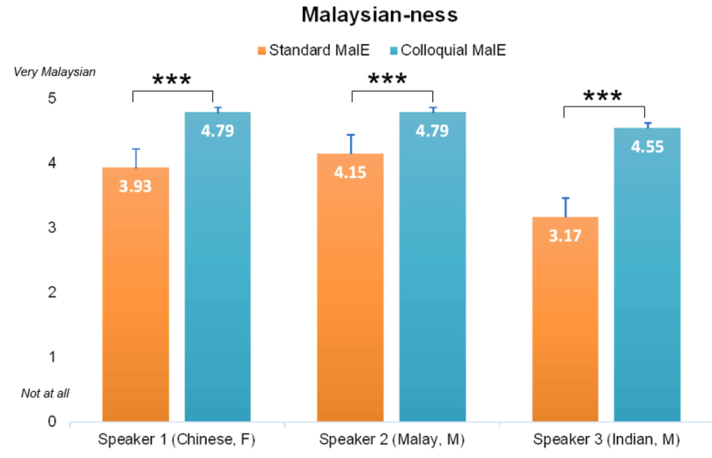
FIGURE 4 Mean evaluations for Malaysian-ness in Standard MalE and Colloquial MalE [Colour figure can be viewed at wileyonlinelibrary.com]
Note: Asterisks represent: *p ≤ 0.05; **p ≤ 0.01; ***p ≤ 0.001

recordings, with means of 4.15 and 4.79 respectively. Considering that this speaker was of Malay background, this suggests that for the respondents, ‘sounding Malaysian’ may be linked to specifically sounding ‘Malay Malaysian’. In the Colloquial Malaysian English guise, some remarked that Speaker 2 seemed ‘impolite’, ‘a little rude’, ‘impatient’, and ‘too Manglish’. Speaker 2 had also been rated the lowest in terms of sounding ‘professional’ for both recordings, suggesting that for the respondents, sounding ‘Malaysian’ is inversely proportional to sounding ‘professional’. For Speaker 3, a stark contrast in ratings of Malaysian-ness emerged across both recordings. One respondent noted, ‘I can feel the rudeness when Speaker 3 uses Malaysian English in Recording 2 as compared to proper English in Recording 1’.
Overall, the results of the matched-guise experiment revealed that attitudes were more positive on the status dimension for the Standard Malaysian English recording (clarity, education, professionalism), but not necessarily so for solidarity; while Colloquial Malaysian English was perceived as sounding much more Malaysian and slightly more sociable, it was neither seen as friendlier nor more likeable. Taken together with the findings from the open-ended questions, it seems that there are varying degrees of acceptance for varieties of Malaysian English.

6.2.1 Ethnolectal differences

Comments provided alongside the ratings showed that respondents were particularly adept at picking up on the speakers’ (actors’) ethnic backgrounds, with many pointing out in their responses the fact that Speaker 1 ‘sounded like Chinese-Malaysian’, Speaker 2 ‘sound[ed] Malay’ and Speaker 3 ‘sound[ed] like Indian’ and ‘I would guess that he’s Indian Malaysian’. Despite not knowing the background of the speakers, nor being given any potentially indexical information, such as first names, along with the fact that no specifically ethnically-marked features were included in the script (belanja, susah and tak tahu are of Malay origin, but are generally viewed as features of everyday Malaysian English rather than specifically ‘Malay Malaysian’ words), the majority of respondents volunteered comments and correctly ‘guessed’ the race/ethnicity, as well as the schooling background, of the speakers. This gives support to Nair-Venugopal’s (2000) proposal that Malaysian English consists of clearly-distinguishable ethnolects. The present results indicate that these differences can be detected based on how the different speakers sound, with listeners (likely) relying on cues such as phonology, prosody and intonation, and perhaps voice quality (see Szakay, 2012), even in a highly constrained environment and relying on relatively short examples of speech.
In the case of Speaker 1, respondents seemed certain that she ‘sounds very Chinese’ and that she was ‘probably from Chinese school’, so respondents could ‘hazard a guess that she’s Chinese-Malaysian’. For Speaker 2, respondents also correctly guessed that he was ‘probably not Chinese-Malaysian’’; however he was also described as sounding like a ‘typical Malaysian Ah Beng’.⁷ As a possible reflection of the Ah Beng stereotype of being uneducated, Speaker 2 was also rated the lowest in terms of education as compared to Speaker 1 and Speaker 3 and in both guises (see Figure 2). On the other hand, respondents explicitly refer to having an ‘English-educated background with a nice accent’ as the reason for Speaker 3 being evaluated as sounding significantly more educated in the Standard Malaysian English versus the Colloquial Malaysian English guise. Another respondent noted, ‘this speaker’s English is a lot more polished than the other two [...] I would guess that he attended international school’. Thus, there may be a second order indexicality (Eckert, 2008) associated with particular cues in the guises, in that something that sounds uneducated may also be indexical of being Ah Beng, or of Malaysian background; whereas something that sounds more educated and more ‘international school’ may be also be indexical of being of Indian background.
A further point of interest was a remark that because Speaker 3 spoke with an accent, this made him sound ‘like a foreign speaker’, and gave the impression that he was ‘speaking better English than us Malaysians’. This recalls the previously mentioned ‘double bind’ (see Section 6.1), with a ‘push and pull’ between the prestige afforded by standard varieties and the solidarity afforded by non-standard varieties, where those using the more prestigious variety are viewed as the ‘foreign speaker’. One respondent noted that because Speaker 3 spoke ‘good English’ he sounds ‘unusual for typical Malaysian’. This was echoed by another respondent who commented that Speaker 3 sounded ‘the most educated and most professional out of the three speakers but doesn’t sound very Malaysian’, which suggests that sounding educated and professional is not necessarily seen as synonymous with sounding Malaysian. The juxtaposition of a proficient ‘better English’ and ‘us Malaysians’ also illustrates the level of linguistic insecurity towards Malaysian English, as a variety that is viewed as separate from ‘better’ varieties of English.

7 DISCUSSION

In response to the first research question (‘What attitudes do Malaysians hold towards the English language more generally, and Malaysian English as a variety specifically?’), English was evaluated as playing a symbolic and instrumental role in Malaysian society, and was associated with educational and economic opportunities. It seems that for many of the respondents, there is a recognisably localised variety of English, Malaysian English, which they have come to identify with in a way that contributes to their identity. From the responses, it appears that the variety of Malaysian English which fulfils this purpose is Colloquial Malaysian English; in other words, the mesolectal-basilectal end of the continuum. Respondents may use Malaysian English to express solidarity, and as an in-group identity marker when speaking with other speakers of Malaysian English, and also to differentiate themselves from speakers of other varieties of Englishes. This supports work by Govindan and Pillai (2009) and Pillai and Ong (2018, p. 150), who write that ‘[t]he local variety of English is seen as a versatile variety that is viable for effective communication and not as a distortion of the English language’.
However, despite the fact that the findings indicate that Malaysians do associate feelings of solidarity with Malaysian English, a certain number of respondents also exhibited a degree of ambivalence and conflicted feelings about their own English. On the one hand, respondents acknowledged the existence of Malaysian English and its representation of Malaysian identity and culture, particularly in in-group communication where intelligibility is not a concern, as speakers share a similar linguistic repertoire. On the other hand, respondents indicated a preference to not use Malaysian English with non-Malaysian English speakers, due to its lack of professionalism and prestige, indicating that respondents remained biased towards exonormative models of English over Malaysian English. Many felt that Malaysian English was ‘ungrammatical’ and ‘not really standard’, especially compared to ‘proper’ and ‘standard’ varieties like British English and American English. They were unable to separate the notion of ‘good English’ from that of the idealised Inner Circle ‘native speaker’, and rarely referred to other world Englishes in their responses. By volunteering a number of self-denigrating comments about their own variety of English, they were, in Lippi-Green’s (1997, p. 42) words, ‘complicit in the process’ of their own subordination. Since these findings differ somewhat as compared to studies by Tokumoto and Shibata (2011), who found that Malaysian students in Malaysia had relatively high levels of confidence with regards to the intelligibility of their accent, there is a chance that the Malaysians living overseas in the present study (see section 5) had had different experiences with relation to their accents, as some of the responses concerning experiences of ridicule or overt commentary on their accents indicated. However, since only 21 of the respondents (27%) opted to report their place of residence as overseas (Australia, Taiwan and Singapore), further research is needed to systematically investigate the effect of time spent abroad on language attitudes among speakers of Malaysian (and other Asian) Englishes.
In order to answer the second research question (‘How are Standard Malaysian English and Colloquial Malaysian English evaluated by Malaysians in terms of status and solidarity?’), a matched-guise experiment which contrasted Standard Malaysian English and Colloquial Malaysian English was administered, and language attitudes on status and solidarity dimensions were elicited. As regards status, the results of the matched-guise experiment indicated that Malaysians evaluated Standard Malaysian English more favourably than Colloquial Malaysian English. Colloquial Malaysian English was associated with lower levels of education, and explicitly stated to be less professional due to the use of local slang and code-mixing.
In terms of solidarity, the survey results were indicative of more positive attitudes towards Colloquial Malaysian English for the Malaysian-ness and sociability traits, but not consistently so for the likeability and friendliness traits. Typically, languages or varieties that are evaluated highly in terms of solidarity tend to be those associated with one’s family life and intimate friendships (Giles & Billings, 2004). The outcome of the survey – that is, respondents showing more favourable attitudes towards Colloquial Malaysian English on the solidarity dimension – was therefore somewhat as predicted. However, the data obtained with the open-ended questions suggested that while a number of respondents felt that Colloquial Malaysian English expressed a casual, friendly Malaysian identity that they could relate to, a number of respondents also felt that its speakers sounded ‘rude’ and ‘impatient’ in the Colloquial Malaysian English guise. In short, there seems to be a lack of consensus as to the level of acceptance and likeability of Colloquial Malaysian English, or at least certain features of Colloquial Malaysian English, by Malaysians. We note that Speaker 1 was the only female English speaker and she was rated as more friendly and likeable in the Colloquial Malaysian English guise as compared to the Standard Malaysian English guise, which was not the case for the male speakers. It is possible that listeners were reacting differently to, or displaying a preference for, a female voice as compared to a male one, although these differences were not statistically significant. There is also a chance that the gender or ethnicity of the listeners themselves may have played a role on the ratings along the solidarity dimension. This was beyond the scope of the present study, but could be examined in future research.
For the third research question (‘How do Malaysians perceive ethnic varieties of Malaysian English, and to what extent are they aware of potential ethnolectal differences?), it was clear that participants appear to be keenly attuned to ethnolectal variation in Malaysian English, judging from the number of (unelicited) responses that commented on the ethnic background of the speakers. Thus, while there is an identifiably distinct Malaysian variety of English, this work corroborates that of Pillai and Ong (2018) and Pillai (2012) that Malaysian English cannot be said to be homogeneous: the internal variation within Malaysian English reflects the multi-ethnic and multilingual makeup of the population, and these perceptual differences are often sufficient to mark out the ethnic background of the speaker. Further research could explore how ethnolectal features are used variably across speakers and within an individual speaker’s repertoire, since, as Pillai (2008, p. 43) notes, ‘it is not uncommon to observe Malaysians weaving from one accent to another’. Further comparisons could also be made with neighbouring Singapore, where there is a similar ethnic/racial profile and language ecology (see Tan 2012). Although the cues provided in the Colloquial Malaysian English guise were multiple (lexical, grammatical, morpho-syntactic, discourse-pragmatic), the fact that each speaker was rated differently within the same guise suggests that there are likely also suprasegmental features that distinguish Malaysian ethnolects, as previously posited by Nair-Venugopal (2000). There is also a possibility that the sections of the script assigned to each specific speaker contained individual lexical, grammatical or morphosyntactic elements of Colloquial Malaysian English that the respondents were particularly sensitive or attuned to (including the words belanja or walao). This invites further research into the perception, social meanings and indexicality of each specific feature in situated contexts of use (see Eckert, 2008); however, this was beyond the scope of the present study.
By examining the responses in light of Schneider’s (2003a; 2003b) five stage model of evolution of New Englishes, it is clear that Malaysian English is well within the nativisation stage (Stage 3), in the sense that English was reported to be of instrumental importance to Malaysians, with high value being placed on the use of English, as well as the ‘mother tongue’, for communication. This was most evident in the mean response rate of 4.45 out of 5.00 for the statement ‘Knowing English is as important as my mother tongue’. Further, in the nativisation stage, the importance of a nativised English for expressing local identity is a key feature (Schneider, 2003a, p. 247). The survey revealed a mean response rate of 4.44 out of 5.00 in response to the statement that English is an ‘important part of their personal identity’. As indicated in the results of the matched-guise experiment in response to the ‘Malaysian-ness’ trait, it is the Colloquial Malaysian English variety with distinct nativisation features that expresses an overt Malaysian identity, in contrast to Standard Malaysian English.
Overall, the survey findings suggest that many respondents hold positive attitudes towards Malaysian English as an expression of Malaysian identity. However, there remains a proportion who continue to apply exonormative standards: they acknowledge the existence and (occasional) use of Malaysian English, but continue to think of it as being deficient or ‘wrong’ compared to standardised English. This is a typical phenomenon of the nativisation phase (Schneider, 2003a), where there is a split between speakers who prefer a localised variety of English, and speakers who want to continue upholding conservative norms, feeding into the ‘complaint tradition’ (Milroy and Milroy, 1991, p. 29) which is characteristic of a transitionary stage between nativisation (Phase 3) and endonormative stabilisation (Phase 4). Schneider (2003b, p. 49) points out that the ‘deliberately decided nationalistic language policy’ of promoting Bahasa Malaysia over English in various domains in recent years has been an impediment to the expansion and development of English in Malaysia. Moreover, while Singapore has emphasised a model of English-based bilingualism, Malaysia continues to grapple with its language policies, and as yet, there is no discernible movement towards the codification of Malaysian English. As a result, English in Malaysia does not appear to have progressed beyond Phase 3, while Schneider (2003a, pp. 260–263) suggests that neighbouring Singapore has progressed into Phase 4. This ‘fossilisation’ may indeed be reinforced by the preservation of ethnolinguistic boundaries in Malaysian English, as evidenced by the responses in this survey, where respondents were finely attuned to, and at times critical of, ethnolectal differences in Malaysian English.

8 CONCLUSION

This study presents a glimpse into the complex nature of language attitudes in a multilingual society such as Malaysia, and how the history and development of English have influenced its position in the community, and corresponding attitudes towards the language. Findings indicate that while overall, English in Malaysia plays an important symbolic and instrumental role, attitudes regarding the acceptability of Malaysian English fall across the entire lectal spectrum, with particular ambivalence and even self-denigration directed towards the more colloquial mesolectal or basilectal end of the continuum. In addition, the various comments provided by the respondents in relation to ethnolectal varieties of Malaysian English raises interesting questions about the relationship between language attitudes and race and ethnicity in Malaysia, which is an area that invites further reflection and exploration. Future work could endeavour to find clearer links between potentially racialised attitudes and ethnolects in Malaysia, with studies incorporating more information on the ethnic and socio-economic backgrounds of the respondents themselves. Specific, isolated features of Malaysian English could also be targeted in further matched guise tests, to gain a clearer picture of the indexicality of certain features in the at times complex and contradictory language ecology of Malaysia.

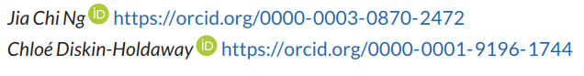
NOTES
¹ Of those living overseas, it is not known how long they had been residing there; however the survey asked participants to: (1) confirm that they were Malaysian citizens; (2) say which state in Malaysia they were from; and (3) confirm, via checkboxes, of the kind of primary (‘National school’, ‘National-type Chinese school’, ‘National-type Tamil school’, ‘Private primary school’, ‘Islamic religious primary school’) and secondary (‘National secondary school’, ‘Chinese independent high school’, ‘International school’) education they received, with only Malaysian school options provided. This gives some indication that the Malaysian respondents residing overseas had still spent their formative years in Malaysia.
² The word mamak originates form the Tamil word mama which means ‘uncle’ and is used to refer to food stalls which are usually run by Tamil men and which are ubiquitous in Malaysia.
³ Since all questions in the survey were optional, not all 77 participants responded to every question in the survey. The number of respondents will be indicated where applicable.
⁴ Rojak is a type of mixed fruit salad, and also means ‘mixture’ in colloquial Malay; it has been used widely to refer to the practice of code-switching and code-mixing in Malaysia.
⁵ Ang moh is used to refer to white (Caucasian) people, and comes from the literal translation of the Hokkien term meaning ‘red-haired’. While it has slightly racist and derogatory overtones, it remains a widely used term in Singapore and Malaysia.
⁶ Banana is a colloquial term that refers to a person of Asian descent who speaks only English, with the implication that the person is an ‘inauthentic’ Asian. The use of ‘banana’ as a metaphor refers to the fact that bananas have yellow skin on the outside, but are white on the inside.
⁷ Ah Beng is a slang word imported from Hokkien, and is used colloquially to refer to a social stereotype of a male with gaudy fashion tastes, and is often associated with low levels of proficiency in English and a working-class background. Typically, it is used associated with and almost always used to refer to Malaysian males of Chinese background, especially Hokkien Chinese.

ACKNOWLEDGEMENTS
This project was approved by the Faculty of Arts Human Ethics Advisory Group (HEAG) at the University of Melbourne (Ethics ID: 1749652.1)2017.

REFERENCES
Asmah, H. O. (1996). Post-imperial English in Malaysia. In J. A. Fishman, A.W. Conrad, & A. Rubal-Lopez (Eds.), Post-imperial English: Status change in former British and American colonies 1840–1990 (pp. 513–555). Berlin: Mouton de Gruyter.
Baskaran, L. (1987). Aspects of Malaysian English syntax (Unpublished doctoral dissertation). University of London, London.
Baskaran, L. (1994). The Malaysian English mosaic. English Today, 10, 27–32.
Coluzzi, P. (2016). Attitudes towards Malay, English and Chinese among Malaysian students: A matched guise test. In T. Yamaguchi & D. Deterding (Eds.), English in Malaysia: Current use and status (pp. 87–101). Leiden: Brill.
Crismore, A., Ngeow, K. Y.-H & Soo, K.-S. (1996). Attitudes toward English in Malaysia. World Englishes, 15, 319–335.
Department of Statistics Malaysia (2020). Current Population Estimates, Malaysia. Retrieved from https://www.dosm.gov.my/v1/index.php?r=column/cthemeByCat&cat=155&bul_id=OVByWjg5YkQ3MWFZRTN5bDJiaEVhZz09&menu_id=L0pheU43NWJwRWVSZklWdzQ4TlhUUT09#
David, M. K., & Govindasamy, S. (2005). Negotiating a language policy for Malaysia: Local demand for affirmative action versus challenges from globalisation. In A. S. Canagarajah (Ed.), Reclaiming the local in language policy and practice (pp. 123–146). Mahwah, NJ: Lawrence Erlbaum Associates.
Diskin, C., & Regan, V. (2017). The attitudes of recently-arrived Polish migrants to Irish English. World Englishes, 36, 191–207. https://doi.org/10.1111/weng.12253
Eckert, P. (2008). Variation and the indexical field. Journal of Sociolinguistics, 12, 453–476.
Garrett, P., Coupland, N., & Williams, A. (2003). Investigating language attitudes: Social meanings of dialect, ethnicity and performance. Cardiff: University of Wales Press.
Giles, H., & Billings, A. C. (2004). Assessing language attitudes: Speaker evaluation studies. In A. Davies & C. Elder (Eds.), The handbook of applied linguistics (pp. 187–209). Malden, MA: Blackwell.
Gill, S. K. (1993). Standards and pedagogical norms for teaching English in Malaysia. World Englishes, 12, 223–238.
Govindan, I. V. P., & Pillai, S. (2009). English question forms used by young Malaysian Indians. The English Teacher, XXXVIII, 74–79.
Kachru, B. B. (1985). Standards, codification and sociolinguistic realism: The English language in the outer circle. In R. Quirk & H. G. Widdowson (Eds.), English in the world: Teaching and learning the language and literatures (pp. 11–30). Cambridge: Cambridge University Press.
Kircher, R. (2009). Language attitudes in Quebec: A contemporary perspective (Doctoral dissertation). University of London, London.
Kirkpatrick, A. (2010). Malaysia, Singapore, Brunei and the Philippines: Linguistic context and the role of English. In A. Kirkpatrick (Ed.), English as a lingua franca in ASEAN: A multilingual model (pp. 19–42). Hong Kong University Press.
Labov, W. (1986). The social stratification of (r) in New York City department stores. In H. B. Allen & M. D. Linn (Eds.), Dialect and language variation (pp. 304–329). London: Academic Press.
Lambert, W. E., Hodgson, R. C., Gardner, R. C., & Fillenbaum, S. (1960). Evaluational reactions to spoken languages. Journal of Abnormal and Social Psychology, 60, 44–51.
Lee, S. K. (2003). Multiple identities in a multicultural world: A Malaysian perspective. Journal of Language, Identity, and Education, 2, 137–58.
Lippi-Green, R. (1997). English with an accent: Language, ideology, and discrimination in the United States. London: Routledge.
Manan, S. A., David, M. K., Dumanig, F. P., & Naqeebullah, K. (2015). Politics, economics and identity: Mapping the linguistic landscape of Kuala Lumpur, Malaysia. International Journal of Multilingualism, 12, 31–50.
Mardziah, H. A., & Wong, B. E. (2006). Listening to the ethnic voice in ESL learning. The English Teacher, 35, 15–26.
Milroy, J., & Milroy, L. (1991). Authority in language: Investigating language prescription and standardization. New York: Routledge.
Morais, E. (1998). Language choice in a Malaysian car-assembly plant. International Journal of the Sociology of Language, 130, 89–106.
Nair-Venugopal, S. (2000). English, identity and the Malaysian workplace. World Englishes, 19, 205–213.
Newman, M., & Wu, A. (2011). Do you sound Asian when you speak English? Racial identification and voice in Chinese and Korean Americans’ English. American Speech, 86, 152–178.
Pillai, S. (2008). Speaking English the Malaysian way – correct or not? English Today, 24, 42–45.
Pillai, S. (2012). Colloquial Malaysian English. In B. Kortmann & K. Lunkenheimer (Eds.), The Mouton world atlas of variation in English (pp. 573–584). Berlin: Mouton de Gruyter.
Pillai, S., & Ong, L. T. (2018). English(es) in Malaysia. Asian Englishes, 20, 147–157.
Platt, J. T., & Weber, H. (1980). English in Singapore and Malaysia: Status, features, functions. Oxford: Oxford University Press.
Rajadurai, J. (2004). The faces and facets of English in Malaysia. English Today, 20, 54–58.
Rajadurai, J. (2013). “They think speaking English isn’t good, you know”: Negotiating bilingual identities in the Malay community. In L. Wee, R. B. H. Goh & L. Lim (Eds.), The politics of English: South Asia, Southeast Asia and the Asia Pacific (pp. 125–144). Philadelphia, PA: John Benjamins.
Ratnawati, M.-A. (2005). English and Islam: A clash of civilizations. Journal of Language, Identity, and Education, 4, 103–118.
Ryan, E. B., Giles, H., & Sebastian, R. J. (1982). An integrative perspective for the study of attitudes toward language variation. In E. B. Ryan & H. Giles (Eds.), Attitudes towards language variation: Social and applied contexts (pp. 1–19). London: Edward Arnold.
Ryan, E. B., Giles, H., Hewstone, M., & Johnson, P. (1987). The measurement of language attitudes. In U. Ammon, N. Dittmar & K. J. Mattheier (Eds.), Sociolinguistics: An international handbook of the science of language and society (pp. 1068–1081). Berlin: Walter de Gruyter.
Schneider, E. W. (2003a). The dynamics of the New Englishes: From identity construction to dialect birth. Language, 79, 233– 281.
Schneider, E. W. (2003b). Evolutionary patterns of New Englishes and the special case of Malaysian English. Asian Englishes, 6, 44–63.
Szakay, A. (2012). Voice quality as a marker of ethnicity in New Zealand: From acoustics to perception. Journal of Sociolinguistics, 16, 382–397.
Tan, P. (2012). English in Singapore. International Journal of Language, Translation and Intercultural Communication, 1, 123–138.
Tan, S. I. (2013). Malaysian English: Language contact and change. Frankfurt am Main: Peter Lang.
Thomas, E. R., & Reaser, J. (2004). Delimiting perceptual cues used for ethnic labeling of African American and European American voices. Journal of Sociolinguistics, 8, 54–87.
Tokumoto, M., & Shibata, M. (2011). Asian varieties of English: Attitudes towards pronunciation. World Englishes, 30, 392–408.
Widdowson, H. G. (1994). The ownership of English. TESOL Quarterly, 28. 377–389.
Wong, I. (1983). Simplification features in the structure of colloquial Malaysian English. RELC Anthology Series, 11, 25–149.

Перевод

Номинация «Перевод научного текста
с английского языка на русский»

