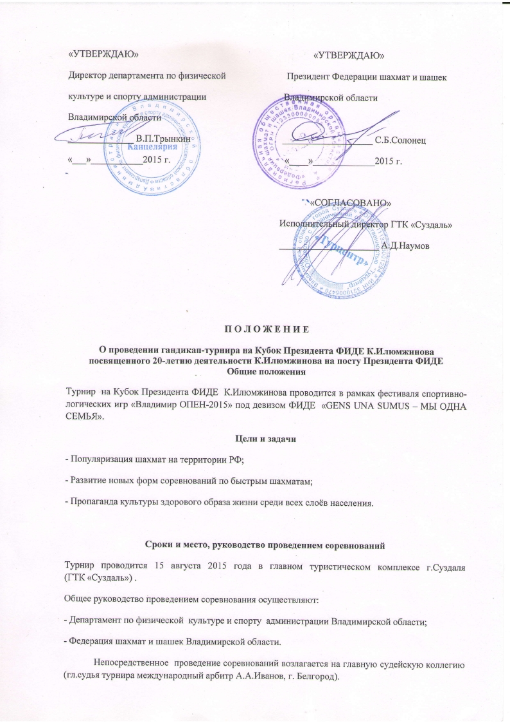

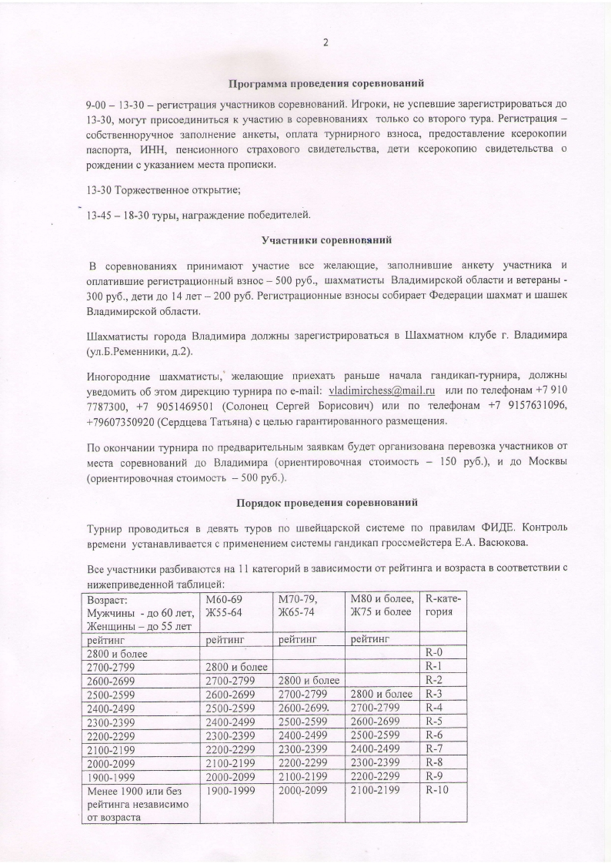

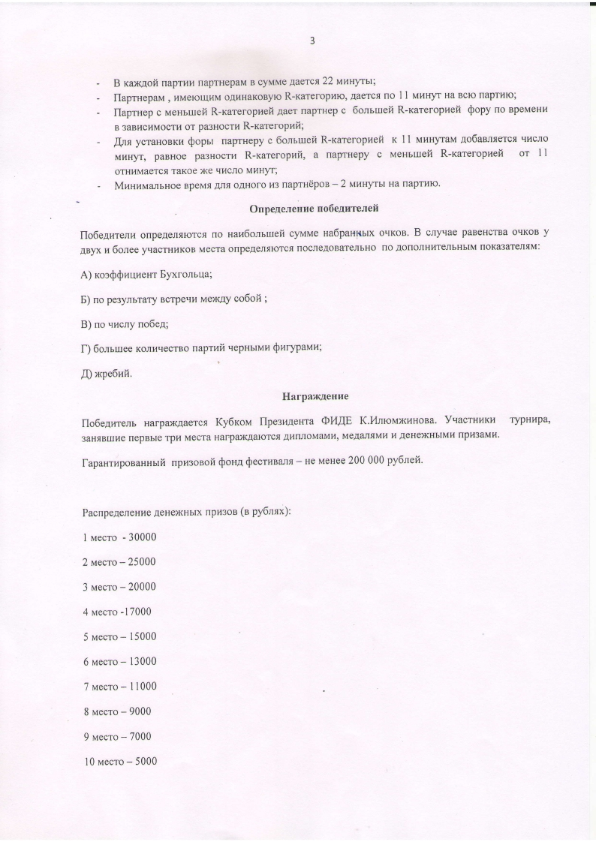

Thank you for evaluating AnyBizSoft PDF to Word.

You can only convert 3 pages with the trial version.

To get all the pages converted, you need to purchase the software from:

http://www.anypdftools.com/buy/buy-pdf-to-word.html

